**PRODUCT DESIGN THINKING FRAMEWORK**

**-QUANTUM UNIVERSITY**

**-01**

**-TASK NO.03**

# **- Create Inference report for the article collected**

*TASK 3*

I pick a **Technological Advancements in the Semiconductor Industry** as per article collected.

**KEY ISSUES**

* Miniaturization & Moore’s Law Limitations
* AI & High-Performance Computing (HPC) Demand
* Heterogeneous Integration & Chipset Architectures
* Material Innovations
* Quantum Computing & Emerging Technologies
* Sustainability & Energy Efficiency

ACCORDING TO THIS PROBLEMS IN A SEMICOUNDUCTOR INDUSTRY I’VE CREATED A FLOWCHART TO UNDERSTAND THE FACT EASILY.

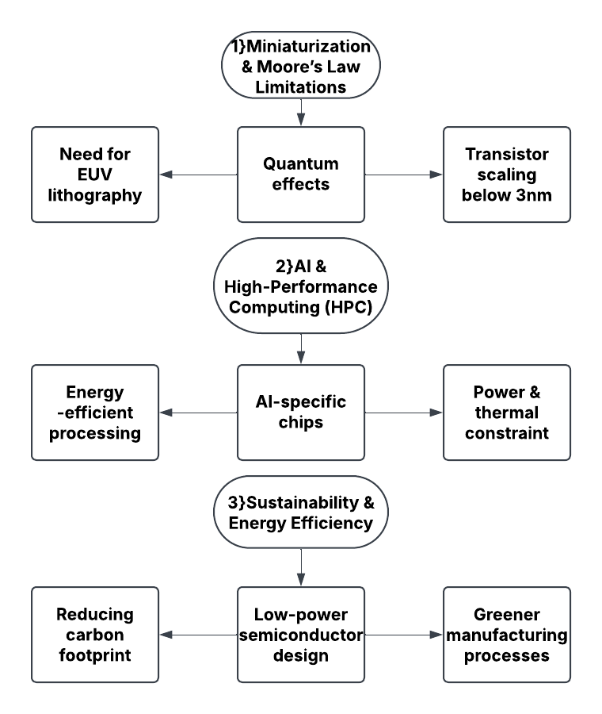

**CONCLUSION**

While technological advancements in semiconductors drive progress, they also introduce challenges in scalability, efficiency, and sustainability.